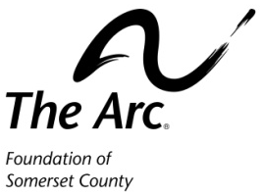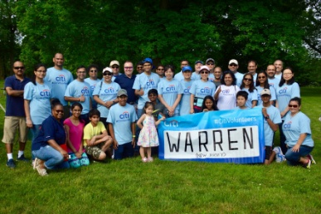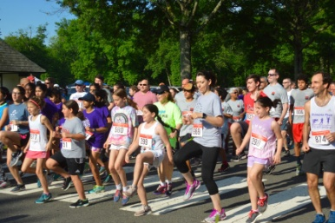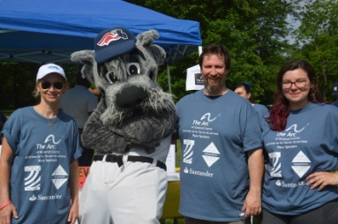

Step Up For The Arc 1.5 Mile Walk & 5K Run – Saturday, April 27, 2019

Duke Island Park, Bridgewater, NJ

Sponsorship Levels

Race Sponsor - $1,000

*Largest Sponsor logo printed on front of walk t-shirt
* Sponsor logo on top of event signs and event web page
* Hyperlink to your website from our event webpage, social media posts and monthly news blasts (Jan-April) and public relations
*Free table and tent at the event to promote your business day of the event

Gold Medal Sponsor - $500

* Extra-large sponsor logo printed prominently on the back of the walk t-shirt
* Sponsor logo on top event signs and event web page
* Hyperlink to your website from our event web page, social media posts and monthly news blasts (Jan-April) and public relations

Host table - $100

*Bring your own table and
tent to promote your
business or service
Bronze Medal Sponsor - $150

* Sponsor logo printed on the back of the walk T-shirt

Silver Medal Sponsor - $250

*Large sponsor logo printed on back of walk t-shirt
* Sponsor logo on event signs

Deadline for sponsorships is Saturday, April 19th. Questions? Call 908-658-3805 Fax: 908-658-3856

Yes, please reserve the sponsorship checked below for my company!

Race Sponsor - $1,000
Gold Medal Sponsor - $500
Silver Medal Sponsor - $250
Bronze Medal Sponsor - $150
Host a Table - $100

I do not wish to be a sponsor, but have enclosed a donation of $____________.

Company: _______________________________________Contact:________________________________

Address:____________________________ City: _____________________ State: ______ Zip: _________

Email: ____________________________________________ Phone:______________________________

Total Amount Enclosed: $ _________ Card number: _____________________________ Exp: ________
(please circle one): Visa MasterCard Amex

* Please email logo artwork before Saturday, April 19th to: lisamariea@thearcofsomerset.org

Please return this form with payment to:

The Arc Foundation of Somerset County, 141 S Main St, Manville, NJ 08835 Att: 5K Event

