Step Up For The Arc of Somerset County 5K Run–Saturday, April 27, 2019
Sponsored by The Arc Foundation of Somerset County
Race Registration Begins at 7:30 am Race Begins at 8:30 am Race Results Announced 9:45 am

Proceeds support programs for children and adults with intellectual and developmental disabilities.
The race will offer $50 in cash to the following:
- 1st place adult male (age 18 & up) - 1st place adult female (age 18 & up)
- 1st place student male (age 10-17) - 1st place student female (age 10-17)
$20 in Cash to the 1st Place Youth Runner (M/F age 5-9)
In order to receive a FREE Event T-Shirt at the event, you must return this completed form with check made out to The Arc Foundation of Somerset County
P.O. Box 903, Far Hills, NJ 07931 no later than April 19, 2019.

Race Official Use Only

Bib # __________

Age __________

Gender ________
*
Adult Runner /Walker(18 & Up) $25

Student Runner (age 10 to 17) $15

Youth Runner (5-9) $5

Please Print Clearly: Name*: _____________________________
Gender:___________ Age on Race Day* ____________ Email:___________________________________________________
Address*: _______________________________________ City: ___________________ State: _____ Zip:___________
Emergency Contact*:_________________________________________________________________
(Name & phone number)
City*: ______________________________________State*: __________ Zip*: __________________
Team Name (if applicable): _____________________________________________________ T-Shirt size: S M L XL XXL
(circle one)
T-Employer/Organization if running with a Company Team: ____________________________________________________
The Arc of Somerset County supports individuals with developmental disabilities and their families from birth through the senior years of life through various programs and services. Today, we serve over 1,400 children, adults, and their families in 33 locations including 27 group homes and apartments, four employment centers, the Jerry Davis Center for Children and Families, and a special needs camp, Camp Jotoni located in Warren, New Jersey.
The Arc Foundation of Somerset County is dedicated to enhancing the quality of life and expanding programs and services for individuals with intellectual and developmental disabilities through the procurement of grants, fundraising, awareness, education, and public relations activities.
Event Location:
DUKE ISLAND PARK
191 Old York Road
Bridgewater, NJ
RAIN or SHINE

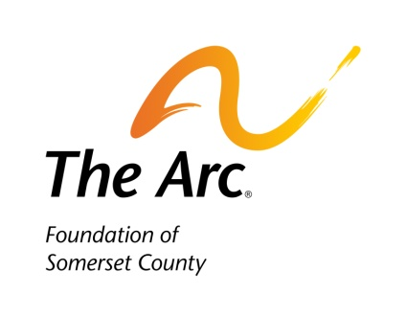
In consideration of being permitted to participate in the 2019 Arc of Somerset 5K Run, I hereby assume any and all risks which might be associated with the event. I further waive, release, discharge and indemnify The Arc of Somerset County, The Arc Foundation of Somerset County, The Somerset County Parks Commission, volunteers, sponsors and others associated with the event from any and all claims for injuries or damage of any kind arising from participating in the 5K Run. I permit The Arc Foundation of Somerset County the free use of my name and picture in any reports and promotions of this or future events. I permit The Arc Foundation of Somerset County the free use of my first name only & picture in any published materials/promotions for this or future events.
.
Name:* ___________________________________________ Signature: ___________________________________________ Date: ______________
Parent or Guardian signature if individual is under 18: _________________________________________________

For questions, please contact Lisa Marie, Director of Foundation Development & Public Relations, at lisamariea@thearcofsomerset.org or at 908-658-3805 Fax: 908-658-3856

