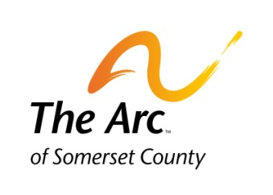
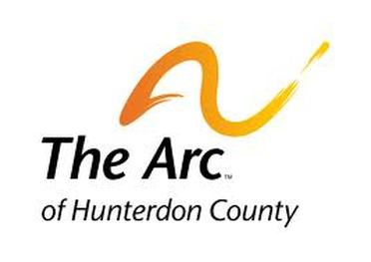
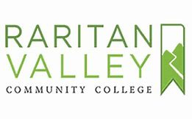
The Achievement Center at Raritan Valley Community College
SPRING SEMESTER SCHEDULE 2020
Registration Deadline is November 15, 2019
MON | TUES | WED | THUR | FRI
College Mgmt |  | 11AM to 12:50PM  CREATIVE WRITER IN YOU II | College Mgmt | College Mgmt
12PM to 1:50PM  EXPANDING COMMUNICATION | 11AM to 12:50PM  CAREER DEV II | 1PM to 2:50PM  SOCIAL SKILLS FOR GROUPS | 11AM to 12:50PM  RESEARCH and the WRITING PROCESS | College Mgmt
3PM to 4:50PM  WRITING OUT LOUD |  | 3PM to 4:50PM  COLLEGE SKILLS and STRATEGIES II |  | CLUB FRIDAY NIGHT HANGOUT 6PM TO 8PM – on Fridays 9 sessions

Notes:
- You can set up a meeting or email selections for Registration – please schedule a time with Bob Hulit, CC, for further discussion
- All classes are subject to Enrollment
- Please refer to our Tuition Policy in terms of Payment Guidelines
- Tuition Payment is due prior to the first day of classes

