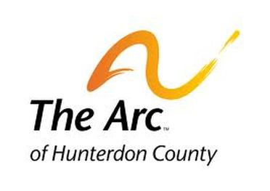
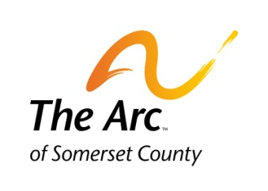
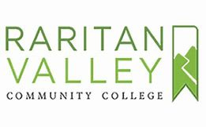
The Achievement Center at RVCC
CLUB FRIDAY NIGHT HANGOUT
Social Skills Awareness Program
(ages 16 years old to 25 years old)

Facilitated by Bob Hulit, Curriculum Coordinator
The Achievement Center at Raritan Valley Community College
January through May – start date Friday, January 31, 2020

This Friday Night Social Skills-based Activities and Recreational program on the campus of Raritan Valley Community College is designed through practice to develop and enhance social skills; recognize the importance of both verbal/non-verbal communication in our relationships, teamwork, and making friends.

Please note this is not a behavioral intervention therapy group. It is designed for our members to gain confidence and work towards emotional and social well-being through social and recreational activities.

Some of the activities we engage in our Arts as Therapy; Importance of Recreation in our lives; Movie Night; Social Skills Olympics, and other engagement activities.

Are You Ready to Get Started?

- CLUB FRIDAY NIGHT HANGOUT will hold NINE MEETINGS in the SPRING SEMESTER from 6pm to 8pm at The Achievement Center (Arts Building – Room A-25) on the campus of Raritan Community College - Start Date Friday, January 31, 2020.
- Cost for the semester is $350 (9 Meetings Total). No transportation will be provided. Deadline for Registration is November 15, 2019 (enrollment availability)
- To learn more information or request an application and set up an interview for the program, please contact Bob Hulit at 732-666-4781 or email us at bobh@thearcofsomerset.org
- Please refer to Tuition Policy in regards to payment deadlines.
- CLUB FRIDAY NIGHT HANGOUT is offered in the Fall and Spring Semesters.

