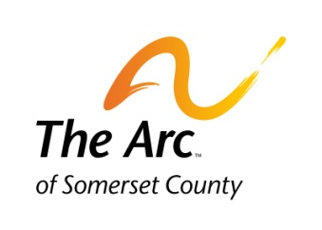
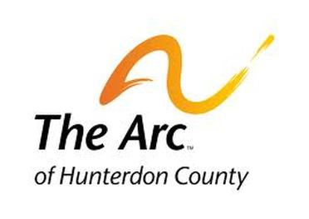

The Achievement Center at
Raritan Valley Community College

READING/WRITING SAMPLE
JUNE 2020 – JUNE 2021

Applicant’s Name:____________________________________
Today’s Date:________________________________________

PLEASE READ THE BRIEF SAMPLE SHORT STORY AND THEN ANSWER THE QUESTIONS ON THE NEXT PAGE TO THE BEST OF YOUR ABILITY. THE DESIGN OF THE ASSIGNMENT IS TO UNDERSTAND YOUR READING COMPREHENSION.

AN OCCURRENCE AT OWL CREEK BRIDGE
BY AMBROSE BIERCE

A man stood on a railroad bridge in Alabama looking down into the swift waters of the Owl Creek River below. The man's hands were tied behind his back. There was a rope around his neck. The rope was tied to part of the bridge above him. Three soldiers of the northern army stood near the prisoner, waiting for their captain's orders to hang him.

Everybody was ready. The prisoner stood quietly. His eyes were not covered. He looked down and saw the water under the bridge. Now, he closed his eyes.
He wanted his last thoughts to be of his wife and children. But, as he tried to think of them, he heard sounds -- again and again. The sounds were soft. But they got louder and louder and started to hurt his ears. The pain was strong. He wanted to shout. But the sounds he heard were just those of the river running swiftly under the bridge.

The prisoner quickly opened his eyes and looked at the water. "If I could only free my hands," he thought. "Then I could get the rope off my neck and jump into the river. I could swim under the water and escape the fire of their guns. I could reach the other side of the river and get home through the forest. My house is outside of their military area, and my wife and children are safe there. I would be, too…"
PLEASE ANSWER THE FOLLOWING QUESTIONS FROM THE SHORT STORY, “AN OCCURRENCE AT OWL CREEK BRIDGE.” DO YOUR BEST TO ANSWER THE FOLLOWING QUESTIONS. YOU CAN TYPE OR PRINT THE ANSWERS. THERE ARE NO WRONG ANSWERS.

- WHO IS THE MAIN CHARACTER IN THE STORY?
______________________________________________________________________________________________________________________________________

- WHERE IS THE SETTING (LOCATION) OF THE STORY?
_________________________________________________________________________________________________________________________________________________________________________________________________________

- WHAT IS HAPPENING TO THE MAN ON THE BRIDGE?
_________________________________________________________________________________________________________________________________________________________________________________________________________

- WHAT ARE THE LAST THOUGHTS THE MAN WANTS TO HAVE?
____________________________________________________________________________________________________________________________________________________________________________________________________________________________________________________________________________

PLEASE WRITE AT LEAST (MINIMUM) FOUR SENTENCES OR LINES AND TELL ME WHY YOU WANT TO ATTEND THE ACHIEVEMENT CENTER PROGRAM? WHAT DO YOU HOPE TO LEARN AND/OR WHAT SKILLS DO YOU WANT TO IMPROVE OR WORK ON?

_____________________________________________________________________________________________________________________________________________________________________________________________________________________________________________________________________________________________________________________________________________________________________________________________________________________________________________________________________________________________________________________________________________________________________________________________________________________________________________________________________________________________________________________________________________________________________________________________________________________________________________________________________________________________________________________________________________________________________________________________________________________________________________

